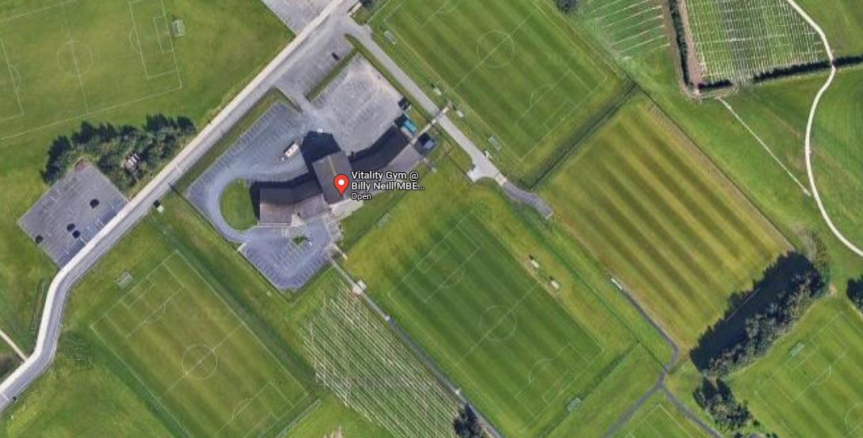

**Male Toilets**

**Female Toilets**

**BUS DROP OFF ZONE**

**FIRST AID**

**PODIUM**

**FOOD UNITS**

**TOILETS**

**VIP / STAFF PARKING**

**CLUB TENT AREA**